Technical Accuracy Booklet for Functional Skills English
Technical Accuracy Booklet for Functional Skills English
Literacy Skills builder
Week 1: Capital letters

What is a capital letter and when do I use one?
Rules:
English uses capital letters to point out important words. This is the one element of English grammar that always follows its rules.
Rule 1: All sentences begin with a capital letter, even sentences that only consist of one word.
Rule 2: The proper name, the name of a specific person or thing, begins with a capital etter.
Rule 3: Titles of books, songs, stories, works of art, magazine articles, tests, and other written materials must begin with a capital letter. Every other important word of the title must also begin with a capital letter. Words that do not need a capital letter unless they are the first word of the title are a, an, and, of, to, the, etc.
Rule 4: The letter I, when used as a pronoun referring to yourself must always be written as a capital letter.
Rule 5: The first word of a direct quotation must begin with a capital letter. For example, "Who's been sleeping in my bed?" Pappa Bear cried.
Rule 6: Titles of people when used with their names or in place of their names must begin with a capital letter. For example, My favorite queen is Queen Elizabeth of England.

When do we use capital letters?
- At the start of sentences.
- For names of people.
- For names of places.
- Days of the week.
- Months of the year.
- Titles of books, films, Songs, Plays etc.
- The first letter inside speech marks: In the distance, I heard someone cry, “Help!”

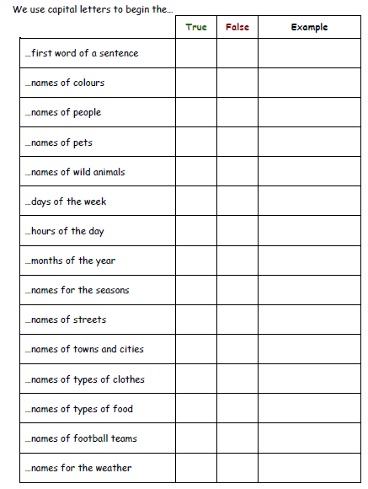
Task 1

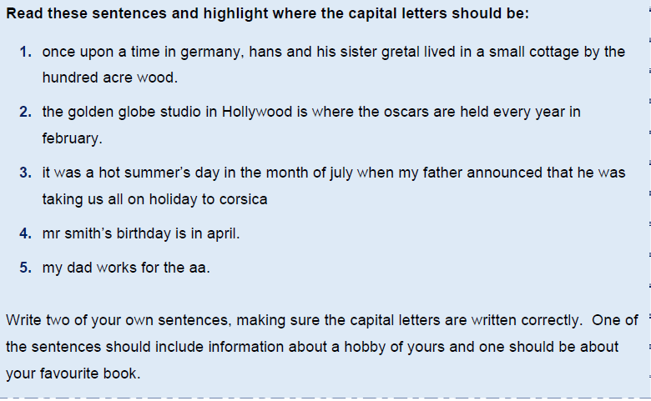
Task 2

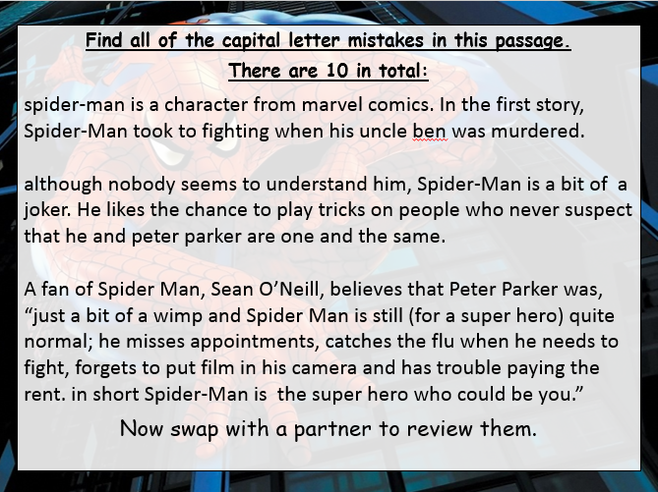
Task 3

Merit Challenge!

Find an example of each capital letter rule in your reading book. Highlight and label it ‘Capital letter rule 1’ for example.

Rule 1: All sentences begin with a capital letter, even sentences that only consist of one word.
Rule 2: The proper name, the name of a specific person or thing, begins with a capital letter.
Rule 3: Titles of books, songs, stories, works of art, magazine articles, tests, and other written materials must begin with a capital letter. Every other important word of the title must also begin with a capital letter. Words that do not need a capital letter unless they are the first word of the title are a, an, and, of, to, the, etc.
Rule 4: The letter I, when used as a pronoun referring to yourself must always be written as a capital letter.
Rule 5: The first word of a direct quotation must begin with a capital letter.
Rule 6: Titles of people when used with their names or in place of their names must begin with a capital letter.

Review learning

Record the rules for capital letter use in the box below. You can bullet point them. No cheating!

Progress timeline

How confident are you with capital letters?

Week 2: Full stops

What is a full stop and when do I use one?
Rules:
A full stop is a punctuation mark (.) used at the end of a sentence or an abbreviation.
BEWARE!
Once you have written a sentence, you cannot put a comma and carry on writing. This is called a run-on error. For example:
I love angel cake, it is my favourite.
(run-on error)

Task 1:

Can you add the capital letters and full stops to these sentences? Highlight the words or letters you have changed

scarlet made her way down the steps to the beach her dog ran behind her wagging its tail when she got to the bottom of the steps scarlet ran to the sea

the waves were breaking on the rocks scarlet decided to make a huge sandcastle her brother came to help her.

the tide began to come in the waves came over the sandcastle and washed it away scarlet and her brother went home

jacob stood on the riverbank watching the boats go by he waved to the people as they went past the engines made a quiet chugging noise

mrs hall got the paints out of the store room she put some on each table connor covered the tables with newspaper then karrina gave out the aprons

the old woman sat on the bench she watched the people as they went past on their way to work it began to rain the old woman got up and went home

Task 2:

In each piece of text identify where the full stops and capital letters go. Re-write the sentences correctly underneath.
pandas are members of the bear family they have black and white fur giant pandas are one of the world’s rarest mammals a young panda is called a cub

beavers are rodents that live in North America they can live in water and on land they are powerful swimmers and can stay underwater for up to fifteen minutes a baby beaver is called a kit kits learn to swim when they are about one month old

bottlenose dolphins send messages to each other they do this by squeaking, whistling or slapping their tails on the water dolphins are mammals like us and breathe air like we do they have a poor sense of smell but very good hearing

Review learning

Record the rules for a full stop in the box below. No cheating!

Progress timeline

How confident are you with full stops?

Week 3: Question marks

What is a question mark and when do I use one?
Rules:
A question mark comes at the end of a question.
“What are you doing?” asked Mr Baker.
A question mark replaces a full stop at the end of a sentence.
A question mark acts like a full stop- you need a capital letter afterwards.
“Are you going on the school trip? I’m not allowed!”
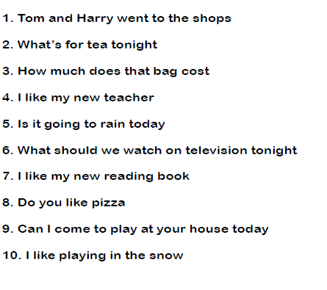
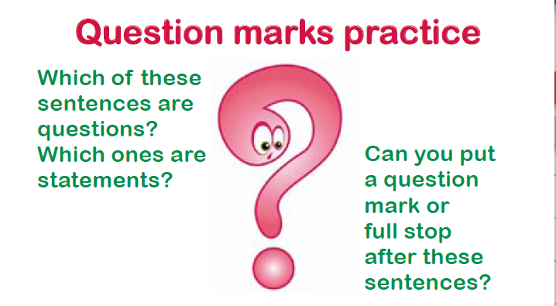
Task 1

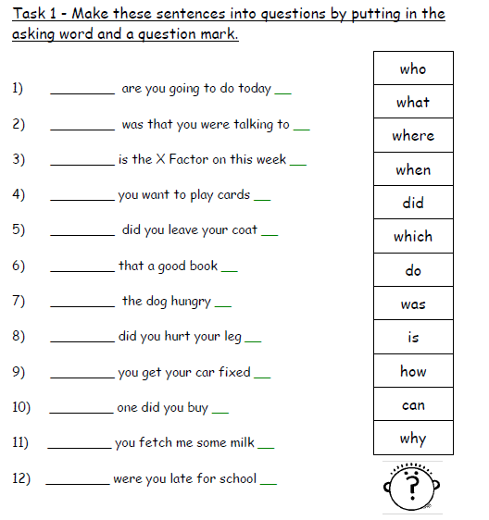
Task 2

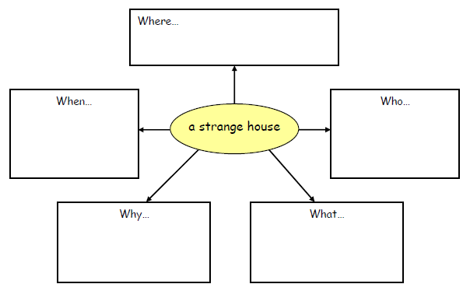
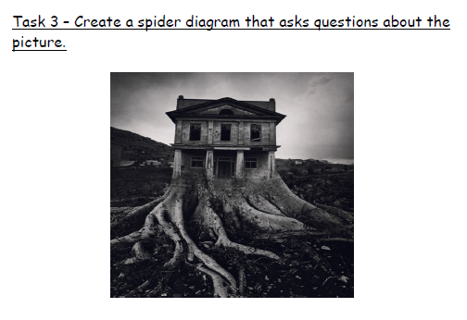
Task 3

Review learning

Record the rules for using a question mark in the box below. No cheating!

Progress timeline

How confident are you with question marks?

Week 4- Exclamation mark!

What is an exclamation mark and when should I use one?
Rules:
An exclamation mark is used instead of a full stop when the sentence written needs emphasising, or someone is shouting.

Sometimes, you use an exclamation mark at the end of a sentence.
It shows when you feel strongly about something or when you are surprised.
My birthday party was brilliant!
An exclamation mark can be used when someone is excited or shouting or if they are saying something that's strange or surprising.
“I've just seen a flying pig!” exclaimed Mr Daly.
N.B: Do not use an exclamation mark unless you are certain it is necessary — and never use two or three of them in a row:
Example: This is a sensational result!!!

Task 1

Read through this campfire story quietly to yourself. Re-write the story in your book, replace some of the full stops with question marks, and add exclamation marks for effect.
When I was a young boy, there was a strange old man on our street named Frank Samuels.

We all called him Frowning Frank because none of us ever saw him smile. He had a mangy old dog he called King that always used other people's gardens for a toilet.

Every morning and every evening, Frowning Frank would take King for a walk and let him do his business in someone's garden. I think King was Frank's only friend.

One evening, while we were playing in the street, Frank came walking down the road, calling loudly, 'King. King. Where are you. Here boy.' He shouted at us, 'Have any of you boys seen my dog.'

We hadn't and we told him so. Frank just kept on frowning and yelling for his dog. About an hour later, he came back looking pretty depressed and headed for his home. He hadn't found King.
Frank looked all around his yard, in the shed out back, under the house and in the bushes in the back yard - no sign of King anywhere.

Finally, he went inside, took off his coat and shoes, and sat down in his chair. He knew he had to call the dog pound. Just as he picked up the phone, he heard a noise like scratching and whining upstairs. He said to himself, ‘What’s that?’ He put down the phone and quietly walked up the stairs in his socks so he could still hear the noise.

When he got to the top, the sound came from still higher up – it was coming from the attic. He climbed the stairs up to the attic door, making no sound in just his socks. He stood outside listening, but he didn't hear a thing. Then he opened the door, stepped in, and…

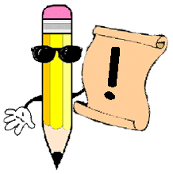
‘ARGHHHHHHHHHHHHH.’
Task 2

Re-write the following sentences, adding exclamation marks where necessary.

- “Look out” shouted James to his brother.

- “Ouch” screamed Charlotte.

- What a wonderful surprise that was

- “Tidy your room” shouted mother. “It’s a pig sty”

- Looking out at the golden sunset, Maria exclaimed, “This is the life”

Task 3

Write a dialogue involving an argument. Use exclamation marks when necessary. Your story could begin with the words:

‘You knew I wanted that!’ Tom cried, rising from the chair.

Review learning

Record the rules for using an exclamation mark in the box below. No cheating!

Progress timeline

How confident are you with exclamation marks?

Week 5- commas

What is a comma and when should I use one in my writing?
Rules:
Commas are used:
1. Commas put a pause in your sentence:
E.G: If you would finish eating your lunch, we could play outside.

2. Commas separates a list of items:
E.G: I like to play with Jan, Jill, Joe and Brad.

3. Commas allow you to combine 2 ideas into a single sentence. (Subordinate/ Dependent Clause)
E.G: While I finished my homework, my friend played the piano.

4. Use a comma after introductory words or phrases.
E.G: Well, you finally finished your homework.

5. Use a comma to show the relation between a word and a noun phrase that follows. (Apposition)
E.G: My teacher, Mr. Clark, is a great singer!

For example:

- When he saw the pirate ship on the horizon, the captain gave the alarm.
- Paul Mann, our star player, broke his leg in the match on Saturday.
- When I go shopping I need to buy: eggs, bread, milk, cheese and butter.

Be careful when using commas as they change the meaning of a sentence.
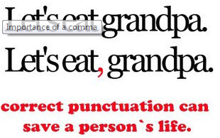

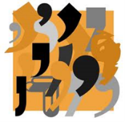
Task 1

Add commas to divide the separate parts of the following sentences.
- Sally bought some flowers for her house but they wilted in the heat.
- Billy had always wanted to be a writer although he didn’t know where to start.
- The boy was excited to go to the theme park but he was too small for the rides.
- Dan’s room was tidy and that was how his mother liked it.
- Amanda’s homework was submitted a day early which was very unusual for her.
Task 2

Using a comma plus a joining word (and, but, although, because, which or who), join these pairs of sentences.
- The dog ate his dinner. He didn’t chase the cat.
- She was upset. She had missed the last train home.
- Tom was at a football match. He had a party to go to later.
- Selma bought some expensive shoes. She now had no money left.
- Fred found a fifty pound note on the pavement. It was a fake.
Task 3

When writing a sentence you often provide additional information to make it more interesting to the reader.

When the second part of a sentence provides extra information about the first part, you divide the two parts with a comma. You can then use the words who, which, where or when after the comma.

E.G: Danny is a very talented football player, which is why he plays for Liverpool FC.

Add extra information to the following sentences by using commas and who, which, where or when.
- My granny is a terrible cook

- Harry ran across the road

- My puppy chewed my socks

- I will meet you at the restaurant

- I have a gorgeous fluffy kitten

Task 4

You can also add information in the middle of a sentence. You need to cushion the extra information with two commas.

E.G: The girl fell off of her chair.
becomes
The girl, who was laughing hysterically, fell off of her chair.

Rewrite the following sentences by adding extra information and commas.
- The man slid into the room.

- My sister is called Rosie.

- The dog bit the postman.

- My friend works in an office.
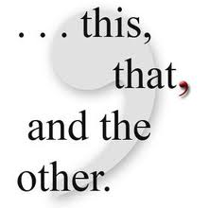

Task 5

Commas are used to separate items in a list. A comma is optional but recommended before an and.

E.G: To build the shed we will need a hammer, nails, and a saw.
Dogs love toys, bones, and long walks.
Robbie is a sweet, caring, and polite boy.

Add commas to the following sentences to separate the items in a list.
- I have travelled to Spain France Italy and Sweden.

- To make a perfect cup of tea you need a teabag sugar milk and hot water.

- Burglars love open windows, dark streets and unlocked cars.

- In London tourists can visit Buckingham Palace London Dungeons and the London Eye.

- The job requires employees to be punctual efficient hardworking and professional.

Review learning

Record the rules for using a comma in the box below. Remember there are 5. No cheating!

Progress timeline

How confident are you with exclamation marks?

Week 6- apostrophes
What is an apostrophe and when do I need to use one?
Rules:
Apostrophes (‘) are used for two reasons:
- to indicate missing letters

For example:
(they + have = they’ve; are + not = aren’t; they + will = they’ll)
- You can't have it.
- Don't do that!
- I'd like an ice-cream, please.
- We'd better hurry.
Apostrophes are used:
- to indicate possession
For example:
- The girl’s bicycle
- My friend’s house
Rules of possession
Singular:
When the possessor is single we indicate possession by using an apostrophe followed by the letter s:
- The man’s coat
- My brother’s car
Plural:

When the possessors are plural, the apostrophe is placed after the final s:
- The boys’ bicycles
- My cousins’ parents
When names end with the letter ‘s’, either use is acceptable:
- James’ wife or
- James’s wife

Task 1

There are some rules to learn in order to ensure that you use the apostrophe for possession correctly.
Rewrite the sentences to include an apostrophe.
Example: The coat belongs to the man = the man’s coat. (Man’s = there is only one man)

- The bicycle belongs to my brother.

- The web belongs to the spider.

- The field belongs to the school.

- The computer belongs to the receptionist.

- The car belongs to my uncle.

Rewrite the sentences to include an apostrophe – remember to look at the s.
Example: The dogs’ bones are hidden in the garden. (Dogs’ = more than one dog)

- The players changing room was like a pig sty after the game.

- The teachers staffroom is very noisy at breaktime.

- The soldiers tank roared across the landscape.

- The doctors surgery was very busy on a Monday morning.

- One of Dickens characters in ‘Oliver Twist’ is the Artful Dodger.

Write sentences containing possessive apostrophes. Make sure you are aware of whether it is singular or plural possessive.

Example: a cat + paw = The cat’s paw had a thorn in it.

- the bicycle + tyre

- Mr Jones + jacket

- three horses + field

- my sister + dress

- fox + prey

Task 2

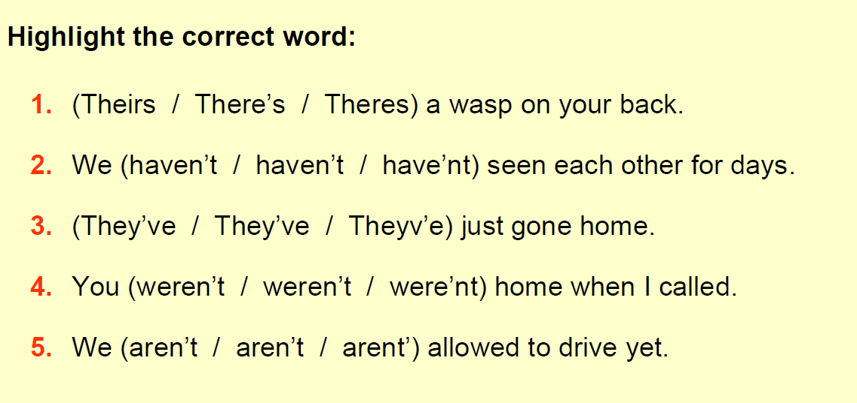
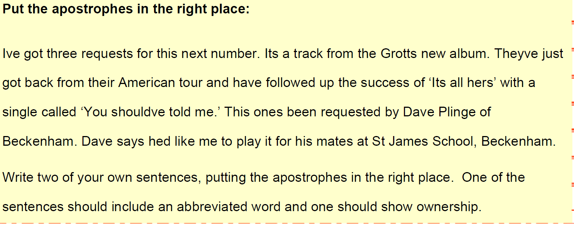
Task 3

Review learning

Record the rules for using an apostrophe in the box below. Remember there are 2 key rules.

Progress timeline

How confident are you with apostrophes?

Week 1- adjectives

What are adjectives and when would I use them?
Rules:
Adjectives are describing words. Large, grey and friendly are all examples of adjectives. In the examples below, these adjectives are used to describe an elephant.
Examples:
• Large elephant
• Grey elephant
• Friendly elephant

Adjectives Modify Nouns
The word elephant is a noun. Adjectives are added to nouns to state what kind, what colour, which one or how many. Adjectives are said to modify nouns and are necessary to make the meanings of sentences clearer or more exact.
Examples:
- Follow the yellow cab.
(In this example, the adjective yellow modifies the noun cab.)

- Craig caught a large bass.
(In this example, the adjective large modifies the noun bass.)

- The rusty nail he stood on was the cause of the infection.

- Please put the old documents in the shredder.

- There is an essential matter we need to discuss.

Adjectives Modify Pronouns
Although less common, adjectives can also modify pronouns.
Examples:
- It is a blue one.
(In this example, the adjective blue modifies the pronoun one.)
Task 1 adjectives
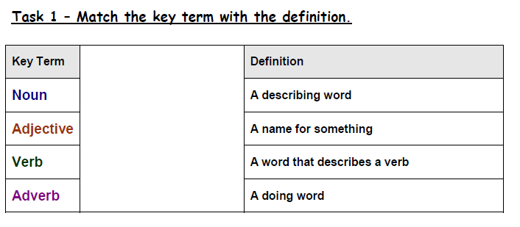

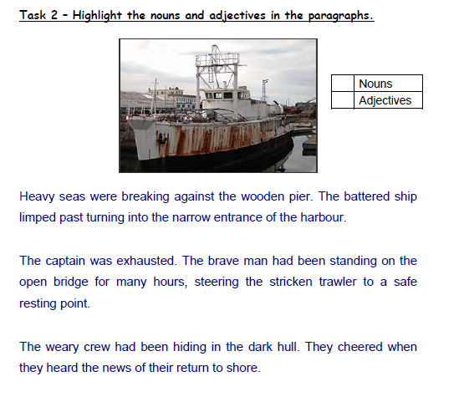
Task 2

Task 3

Write the adjectives in the box in the correct column.
Can you add any of your own?
Delighted | Vital | Careless | Enormously | Derogatory | Tremendously
Satisfactory | Appropriate | Convenient | Successful | Effective | Detrimental
Degrading | Unfortunate | Extremely | Hugely | Agreeable | Content
Satisfied | Profoundly | Grievous | Ecstatic | Aggressive | Sorrowful
Blissful | Crucial | Painful | Joyful | Discouraging | Miserable
Acceptable | Valuable | Exceptional | Essential | Poor | Incorrect
Truly | Elated | Greatly | Insulting | Necessary | Serious

Important | A lot / Very / Really | Good | Bad | Happy | Sad
Task 4

Re-write the following sentences using vocabulary from the table. You can make any changes necessary in the sentences as long as you keep the general meaning. Forbidden words: thing, stuff, really, very, a lot, important, happy, sad, good and bad.
- I felt so sad! I couldn’t find where I had written down that very important number.

- I’m happy because Christmas is near! Christmas always makes me feel good.

- I think it’s a bad thing when people feel sad and they’ve got no one to make them feel happy.

- My best friend has changed a lot lately, I hardly recognise her any more, and sometimes she’s got such bad ideas!

- Last night when I went to bed it was very hard to go to sleep, but I was feeling so sad that it was no good.

- Some people are very good at some subjects but usually it’s because they work a lot to get good grades.

- To my mind, the most important thing about the exams is getting a good mark.

- Sometimes if I get bored a lot, I space out and then I miss really important stuff that teachers say.

Review learning

Record the rules for using an adjective in the box below.

Progress timeline

How confident are you with adjectives?

W
Week 2 adverbs and adverbials

What is an adverb/adverbial and when would I use one?
Rules:
It is a word that tells us more about verbs.
Many adverbs tell us how something is done.
When answering the question 'how', adverbs are usually created from adjectives with an added ly ending. E.g. quick becomes quickly.
An adverb is a word that describes a verb (an action or a doing word).
He ate his breakfast quickly.
The word quickly is an adverb. It tells us how he ate (the verb) his breakfast.

Adverbial phrases
Sometimes more than one word can do the adverb's job. This is called an adverbial phrase.
He ate his lunch really quickly.
The words really quickly are an adverbial phrase. Words like very, more, really and extremely are often used to make an adverb even stronger.

Where can I put an adverb?
Adverbs and adverbial phrases can come before or after a verb.
He quickly ate his lunch.
He ate his lunch quickly.

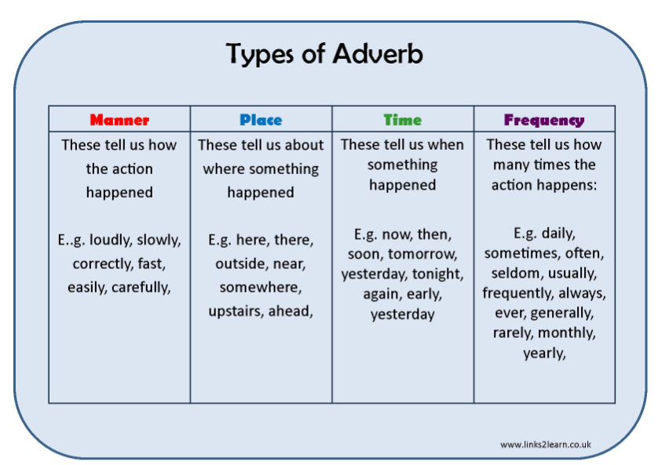

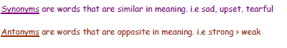
Task 1

In each sentence, underline the adverb. Then come up with a synonym and antonym for each adverb.

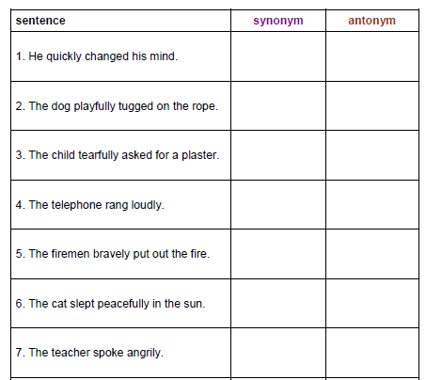

Task 2

Rewrite these sentences to include the adverb shown in the brackets. Show the adverb at the beginning (B), in the middle(M) and at the end(E).

The man spoke to his neighbours. (angrily)

(B)_______________________________________________________
(M)_______________________________________________________
(E)_______________________________________________________

The Princess moved across the room. (gracefully)

(B)______________________________________________________
(M)______________________________________________________
(E)______________________________________________________

He walked along the plank. (nervously)

(B)_______________________________________________________
(M)_______________________________________________________
(E)________________________________________________________
Task 3

In the box below, write 4 sentences. Each sentence must contain at least 1 adverb from the columns above. E.g. manner: “Carefully, Timothy unwrapped the china plate he had bought for his mother.”

1.

2.

3.

4.

Review learning

Record the rules for using an adverb and adverbial in the box below.

Progress timeline

How confident are you with adverbs and adverbials?

Week 3-verb

What is a verb and when would I use one?

Verbs are doing words. A verb can express a physical action, a mental action, or a state of being.

- A physical action (e.g., to swim, to write, to climb).
- A mental action (e.g., to think, to guess, to consider).
- A state of being (e.g., to be, to exist, to appear).
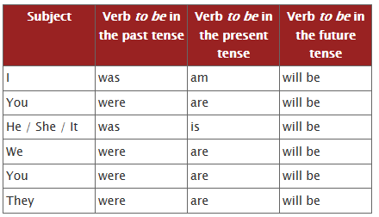
The verbs which express a state of being are the ones which take a little practice to spot, but, actually, they are the most common. The most common verb is the verb to be. That's the one which goes:

There are many different types of verbs.
Modal verbs: can; could, shall; should; may; might; must; will; would
- Give information about the mood of a verb, expressing such things as:
- Obligation (You MUST be home by midnight, he OUGHT to pay before leaving)
- Recommendation (You SHOULD ring and apologize)
- Possibility (I MAY do as you ask, but then again I MAY not)
- They change the meaning!
For example, ‘may’ and ‘can’ operate in the present tense and ‘might’ and ‘could’ are in the past.
Have you every asked someone if you ‘can’ do something, instead of ‘may’?
Student: Can I go to the loo?
Teacher: I don’t know, can you?
Imperative verbs: Think of these as the bossy verbs!
The Imperative creates mood and gives us a command
(Can also be seen as an instruction, or bossy verbs)
Chill out!
Do as I say!
Don’t eat the daisies!
Please be quiet!

Task 1

am is are was were
-followed by the present or the past participle
e.g. I am going to the park. ( am = verb to be; going = present participle)
I was beaten by a better player.(was =verb to be; beaten = past participle)
Underline the verb to be and the present participle.
- I am reading my book.
- You are talking too loudly
- He is eating his lunch.
- She is washing her face.
- They were going home.
- We were playing on the lawn.
- Ellie and Zoe were singing out of tune.
- Emily and Maddy were singing in the choir.
- She was not working hard.
10.They are coming home with us.
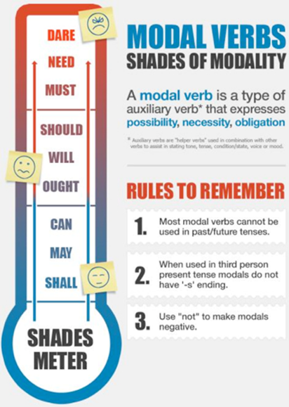
Task 2

Let’s add a modal verb in the gap provided in these sentences to show necessity, possibility, or obligation. Rewrite them underneath.
- I ( ? ) read a good book on my bus trip.

- Suddenly, she realised it ( ? ) be a good idea to hurry up.

- ( ? ) you want a longer lunch hour?

- ( ? ) we change our minds about this?

- Various people think they ( ? ) need answers to this

Now make your own sentences using these modal verbs. They can be questions or statements.
- 1. Could

- 2. Shall

- 3. Will

- 4. Can

- 5. Should

Extension: Can you make these sentences all part of a paragraph on one topic?

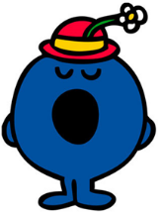
Task 3

Mr. Chatterbox has made all Little Miss Bossy’s sentences too long! They don’t sound bossy anymore! Can you help Little Miss Bossy cut out words to turn them into sentences with bossy verbs? Remember! Bossy verbs and sentences sound like commands and instructions.

- Please could you come over and fold the paper in half?

- Could you carefully drive to the hotel?

- Please pour the milk into the bowl.

- When you are ready, line up at the door.

- Take your coats off, but please do it carefully.

- Gently remove the jelly from the mould.

- If you want to, cut along the dotted line.

- When you have time, add the icing to the cake.

- Please close the door after you.

- I think you should turn right at the traffic lights, don’t you?

Review learning

Record the rules for verbs, modal verbs and imperative verbs here.

Progress timeline

How confident are you with verbs?

Week 4- Preposition

What are prepositions and when do I use them?
Rules:
A preposition is a word that joins a noun to the rest of a sentence.
It explains where the noun is.
The bag was on the table.
The girl walked under the scaffolding.
It sat among the bushes.
The cat sat under the bush as it was raining.
The girl walked slowly across the playground.
Helen put the book on the table.
The postman posted the letter through the letterbox.
James was hiding behind the sofa.

The sentences would not work without the prepositions.

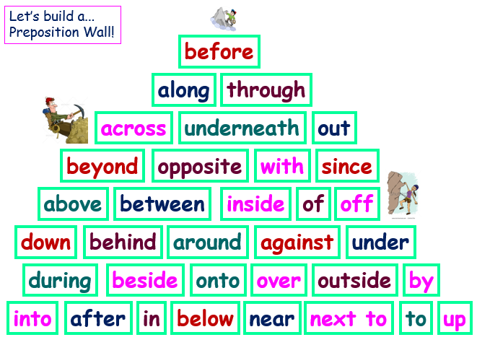

Task 1
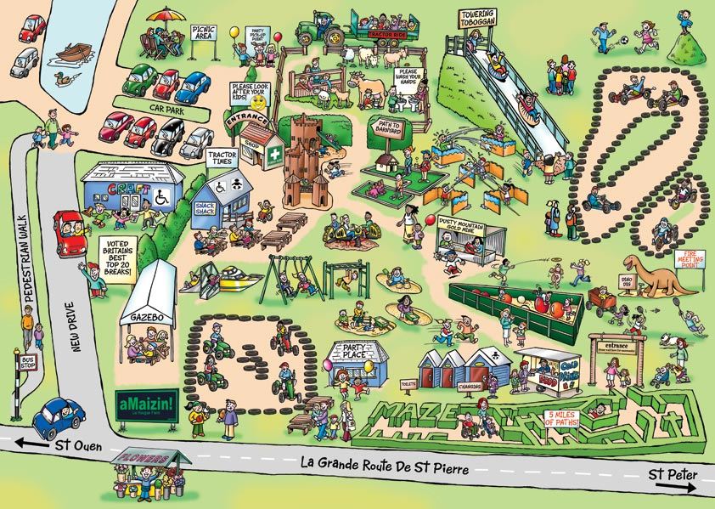
Look carefully at this picture of a Fun Park.
Write at least 8 sentences using a different preposition each time.
e.g. A boy is hanging underneath the monkey bars.

You can add names, colours, shapes and sizes to make your sentences more interesting.
e.g. Oliver is swinging his legs wildly and shrieking excitedly underneath the monkey bars.

Task 2

- A preposition shows the relation of one object or phrase to another.
- The most common are of ‘time’ and ‘place’.
- The sentences below are missing the prepositions! Use your understanding of prepositions of time to fill them in correctly.
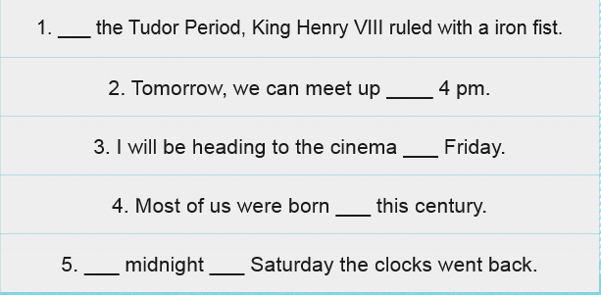
Time

Place
- Using your understanding of prepositions of place, create sentences using the nouns below and don’t forget to use the correct preposition of place.
- 1. Buckingham Palace

- 2. train station

- 3. my friend’s house

- 4. Topshop

- 5. Roof
Task 3

Read the following sentences carefully and add the correct preposition (the “where does it go” word) from the list.

For example, with the sentence “The cat slept ………. the bed” the preposition would be “on” to make the sentence “The cat slept on the bed.”

Here is your list of prepositions:

next up near under in down
beside above on by over behind
in front of across between against through into

A helicopter flew ……………….. my street today.

It took the little boy a while to get ……………….. the stairs.

My keys are ……………….. the table.

My slippers are ……………….. the bed.

That bus drives ……………….. my house.

The bird flew ……………….. into the air.

The car is parked ……………….. the garage.

The chef walked ……………….. the kitchen.

The dog hid ……………….. its owner.

The ladder was leaning ……………….. the wall.

The little girl climbed ……………….. bed.

The man parked his bike ……………….. the shop.

The man sat ……………….. to me on the bus.

The menu was displayed ……………….. the counter.

The motorbike drove carefully ……………….. two big lorries.

The remote control is ……………….. the TV.

The teacher stood ……………….. her desk.

The woman walked ……………….. the road.
Review learning

Record the rules for using prepositions in the box below.

Progress timeline

How confident are you with prepositions?

